Daniel Schwartz  
Social Network Analysis 09-27-2022

Assignment 3

1. 0 1

0 0.16 0.07

1. 0.04 0.16

Communication relationships *do* tend to occur between executives of similar seniority, as we see the 1–1 value and 0–0 value are both much higher than the mixed relationships

1. E6 receives the most citations: 8 citations. E32 and E18 receive the least, both receiving 0 citations.

Color represents seniority (Green=More Senior, Red=Less Senior)

Shape represents office

Size represents in degree (Bigger=Higher In-Degree)

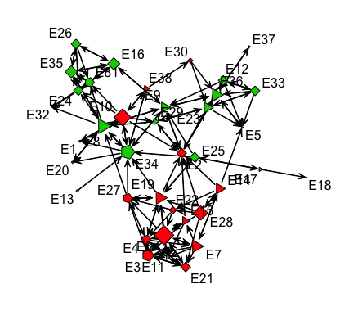

1. More senior executives do not necessarily appear to be more central. We see both red shapes and green shapes have similar sizes, meaning that they have a similar indegree as well.
2. The less senior executives who are most essential are E6 and E10.
3. In the graph below, I represent color gradient as degree centrality, with warmer colors being a higher degree. I represent seniority as shape, with squares as more senior and triangles as less senior. And I represent size as number of projects completed. I find this graph representation insightful because it shows us something we haven’t seen yet. While more experienced people who have completed more projects are cited a decent number of times (shown by their bluish red color), they aren’t the ones who are asked the most. The most red (highest degree) are the smaller shapes, or those who have less projects under their belt. This is interesting because I would have hypothesized that people with more projects/experience would have been cited more, but it turns out there are up and coming academics who have few projects but many citations.

